2000 BOMBARDIER GLOBAL EXPRESS – S/N 9046
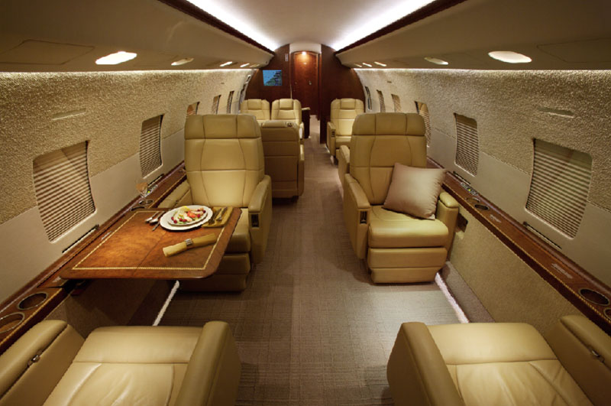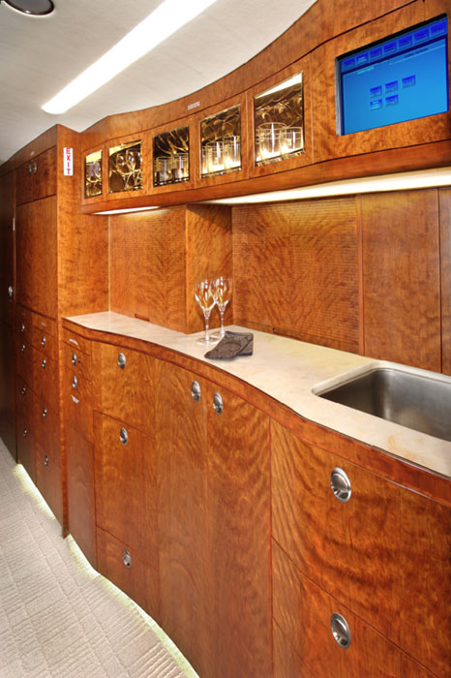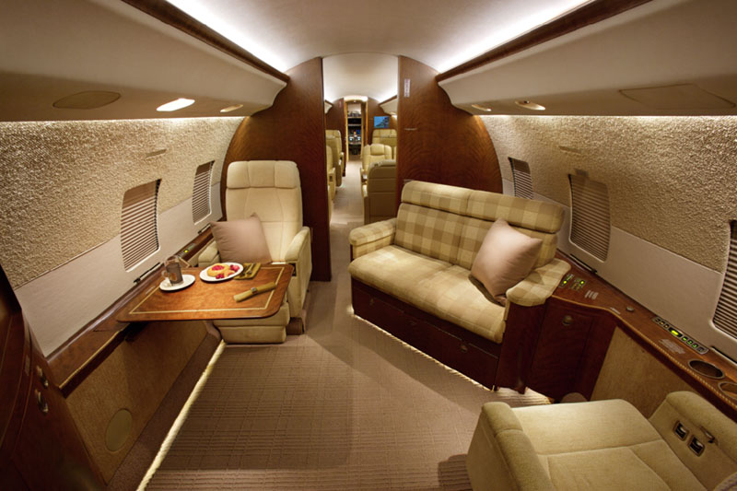

Airframe
• Total Hours: 2311.4*
• Total Landings: 1042
• Bombardier Smartparts Plus
• CAMP Maintenance Tracking Program
• High Service Bulletin Status
• JSSI Engine Program

Engines
• Rolls Royce BR710
• Left & Right: 2311.4 Hours*
• APU: 2038 Hours*

Equipment
• RVSM
• Jumpseat
• Airshow
• Direct TV System
• Built-in Fax Machine
• Three 21.3 inch Video Monitors
• Game ports
• Inside Refuel/Defuel panel
• Tel-Tail Lighting System
• Baker Cabin Management System
• DVD/CD/VHS Entertainment
Systems
• Camera System w/ 5 External Cameras
• Forward and Aft Magair Vacuum
Toilets
• Aft Equipment Bay contains:
Tow Bar Head Storage
Doorstep Ladder
Exterior
• Original Paint (2001)
• Window Frames Polished Aluminum
• White/Grey/Blue

Interior
• 12 Passenger Seats
• Crew Lavatory
• Forward Closet
• Large Forward Galley
• Convection Oven/Microwave
• Single Berthable Seat Crew Area
• Executive Club Chairs Fully
Recline and Swivel
• Conference Grouping
• Hi-Lo Manual Conference Table
• Fwd & Aft Entertainment Cabinet With
Monitor and A/V Equipment
• Two Club Seats
• Two High Back Executive Chairs
• 2 Place Couch Converts to Double Bed
• Large lavatory
• Numerous Storage Drawers
• Large Wardrobe Compartment
• Large Baggage Compartment
Avionics
• Honeywell Primus 2000XP Integrated
System
• Six Tube EFIS
• EICAS
• Dual fail-operational autopilot
• Dual Integrated NZ2000 FMS
Upgraded to CDU 820’s
• Dual 12 Channel GPS
• Dual Full Flight Regime Auto Throttle
• Triple LASERREF III IRS
• Primus 880 Color Weather Radar With
Dual Control Heads
• Lightning Sensor
• Triple Primus II Integrated Nav/Com
• Mode “S” Diversity Transponder
• 8.33 KHz Channel Spacing
• Dual Radar Altimeter
• SELCAL System
• Cockpit Voice Recorder
• Flight Data Recorder
• Artex ELT
• Magnastar C2000 Airborne Telephone
• Honeywell MCS6000 6-Channel Satcom • Data Loader
• Teledyne Datalink System (ACARS)
• Electronic Standby Instrument
• CAIMS
• TCAS II
• EGPWS
• RAAS

Weight Limitations: MTOW 96,000 MLW 78,600 MZFW 56,000 BOW 51,800

